Turkey Creek Sewer Leak Analysis - Bartlesville, Ok - December 2022
January 10, 2023
by William Henning and Susan Henning, Blue Thumb Volunteers; with assistance by Caylen Lee and Carson Lee

Summary
Turkey Creek originates in pasture land east of Bartlesville, Oklahoma and flows through the eastern part of the city, eventually emptying into the Caney River. As part of the Oklahoma Conservation Commission Blue Thumb program, the creek is sampled monthly for water and habitat quality at a location just downstream of where the creek crosses Washington Ave (US Highway 75).
A major concrete sewer pipe runs beside much of the creek, extending from Washington Ave to Silver Lake Rd. Some of the pipe is partially exposed above ground and there are at least two exposed waterway crossings. Leakage was observed at one crossing over a drainage ditch (located just north of the Pathfinder trail and north of Lee Lake). The ditch drains directly into Turkey Creek, approximately 75 ft from the leak point via a culvert that passes under the paved trail.
The normal Blue Thumb monthly Turkey Creek water quality sample was taken on December 18, 2022 (upstream of sewer leak). To quantify the sewer leak effect on water quality, two additional samples were taken and analyzed for specific properties, including the leak itself and creek water downstream of the leak. See map (Figure 1) for sample locations.
Based on ammonia nitrogen analysis and coliform bacteria cultures, the sewage leak had no significant effect on water quality at the downstream sample site within the accuracy of testing. This was likely due to the low relative volume rate of the leak compared to the creek flow rate (dilution effect). It is also possible that some filtering of the drainage ditch water (containing the leak) occurred through silt or debris in the ditch and culvert.

Discussion
Turkey Creek flow rate was considered as normal on the day of sampling. Analysis results are shown in Table 1.
The high ammonia nitrogen content (well above test limits of 4 mg/liter) of the leak water sample was consistent with raw sewage water. For both the upstream and downstream samples, the ammonia content was below test detection limits (< 0.1 mg/liter), indicating no significant stream contamination by the sewer leak. Although, some oxidation of ammonia may have occurred in the stream.
Three 1 ml water samples were taken at each sample location for bacteria analysis. These were cultured in separate petri dishes with a dyed gel medium (Coliscan Easygel formulation). E-coli bacteria appeared as purple spots, and other coliform bacterias appeared as pink spots. For each dish, the spots were counted and the average for each sample point was reported as CFU/ml (see Table 1). Note that the total coliform bacteria data included both purple and pink spots. Figure 4 shows a visual comparison of representative culture dishes for each sample location.
Both E-coli and total coliform bacteria decreased significantly from the upstream to the downstream sample locations. As a minimum, this indicates no significant contamination by the sewer pipe leak at the downstream location. The reduction was surprising, but there are reported mechanisms by which coliform bacteria concentration may decrease in a flowing system by solar radiation exposure, microbial predation, or contact with sediments. Additional dilution by influx of small drainages between the upstream and downstream points (including Lee Lake outflow) may also have contributed to the bacteria concentration decrease.
Observed over time, the sewer water leak rate varied, increasing after major rain events and decreasing, sometimes stopping, during dry periods. On the day of the special samples (December 18, 2022) the leak was a steady drip through a joint clamp on the pipe underside (see Figure 2). Figure 3 shows a higher rate spew photographed on March 15, 2021 after a major rainfall event. Presumably, influx of rainwater or ground water into the sewer system increases the flow rate and hydrostatic pressures in the piping, thus increasing the leak rate.

Table 1: Analysis Results
Sample | Ammonia Nitrogen, mg/L | Total Coliform  Bacteria,  CFU / ml | E-Coli Bacteria,  CFU / ml | Water Temperature, ºC
Upstream (normal Blue Thumb monitoring location near Washington Ave) | < 0.1  (Below Detection Limit) | 173 | 64 | 3
Sewer Leak Water | >> 4  (Well above test range) | (Too numerous to count) | (Too numerous to count) | -
Downstream (located at Silver Lake Road crossing) | < 0.1  (Below Detection Limit) | 48 | 8 | -
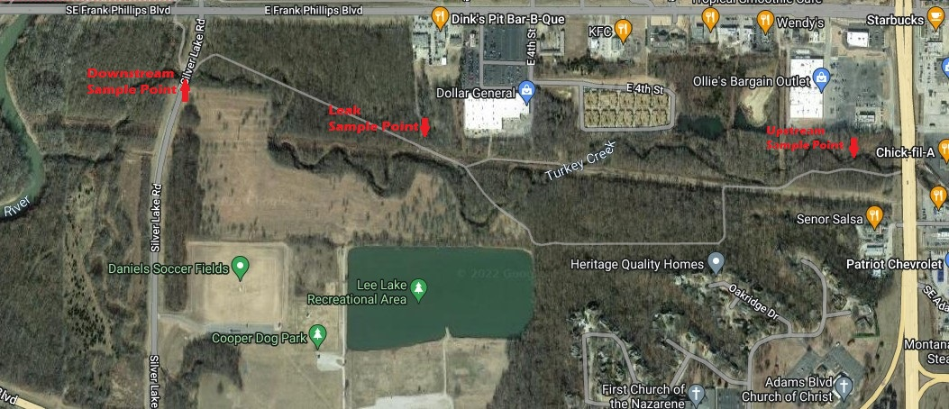
Figure 1: Sample Point Map

Figure 2: Sewer Pipe Leak Detail

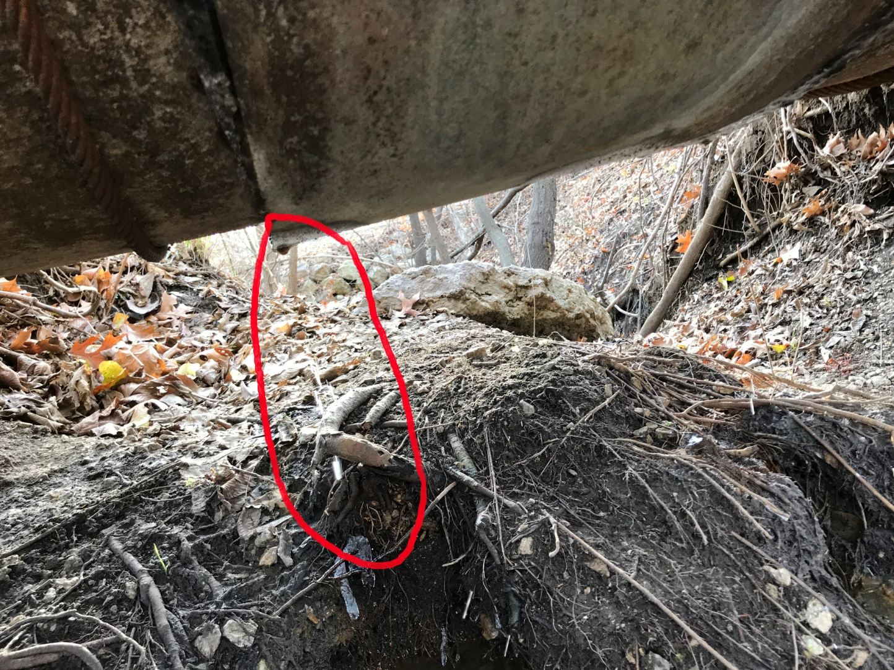

Figure 3: Sewer Line Leak, March 15, 2021

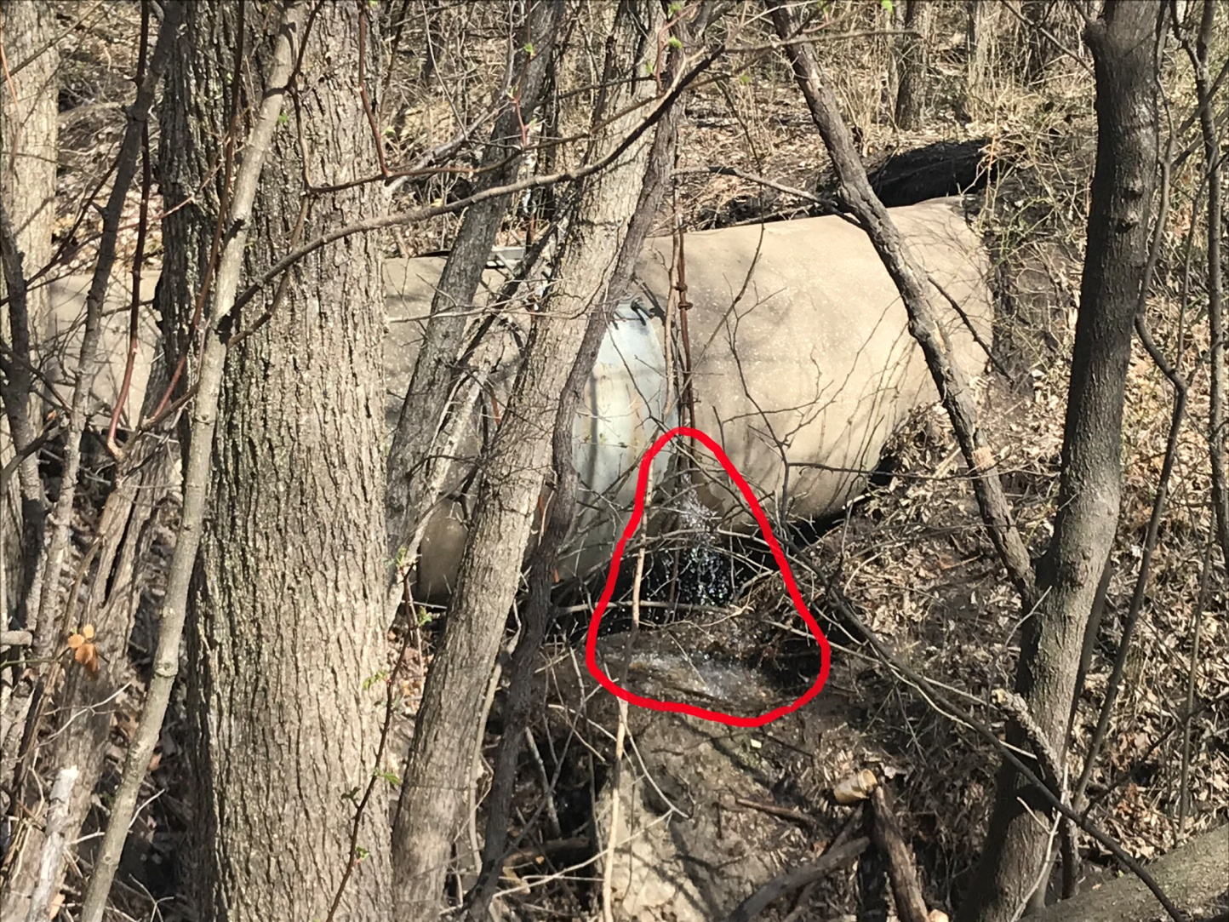

Figure 4: Comparison of Typical Bacterial Culture Plates by Sample Location
[Top - Sewer Leak; Middle - Downstream; Bottom - Upstream]
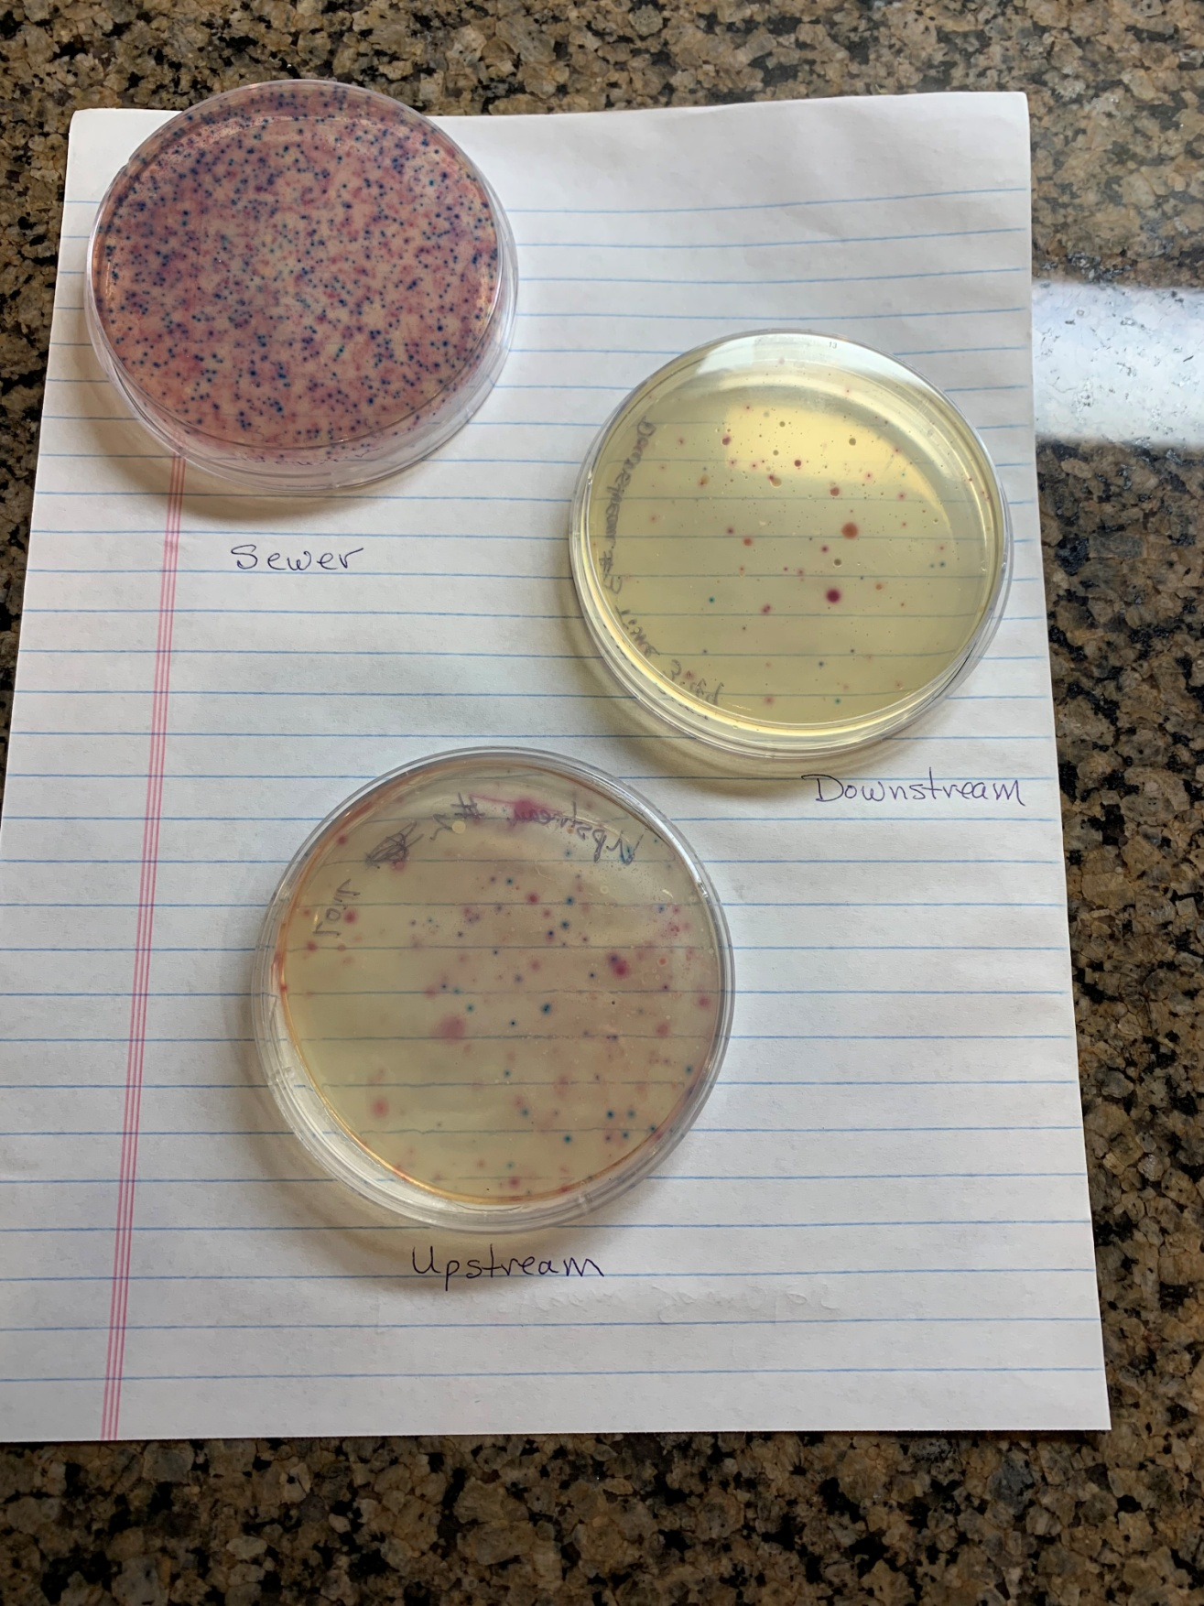

Addendum - Repair Update
July 31, 2023

The City of Bartlesville made repairs to the sewer line leak, starting February 2023. The repairs consisted of a concrete cradle and earthen dam to support the sewer line where it crossed the drainage ditch. By fully supporting the concrete sewer pipe along its length, sagging is eliminated, which may have before caused a leak to open at a joint bottom. Pictures of the repair is shown following.
By all subsequent observations, the leak has stopped.

Figure 4: Sewer Pipe Repair - Initial Construction - February 2023
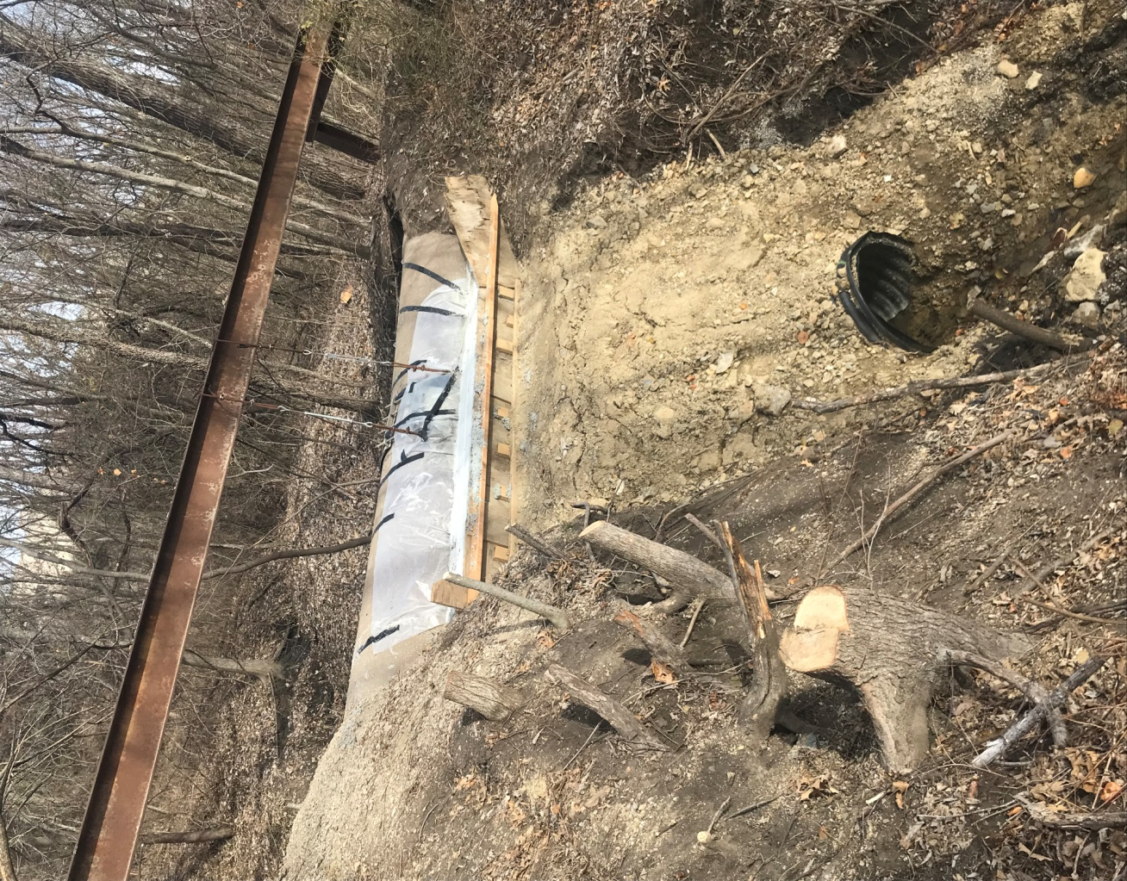

Figure 4: Sewer Pipe Repair - Construction Complete - July 2023
